**A FULL STACK CAPSTON PROJECT**

**PROJECT NAME – FOODBOX**

**Developer Name – Pritesh Vaman Ingale**

**Email id -** [**pritesh1272@gmail.com**](mailto:pritesh1272@gmail.com)

**Contact No – 9172158003**

**GitHub link -**

**Project Description: An ecommerce Application design for the food delivery purpose using this application we can buy a food and do payment online and it include admin page and user page user can buy food and give feedback and there is admin dashboard who can handle this application. Example - He can add, delete, update food and maintain the Customer list**

**Environment:**

**Backend – Java 8, Spring Boot 2.7.5, Spring Data JPA 2.7.5, Swagger(Documentation),**

**Database – MySQL**

**Frontend – Typescript, JavaScript, Angular 15 , HTML , CSS , JQUERY , Angular Material**

**DevOps Tools – GitHub, Jenkins, Docker(for learning purpose)**

# Backend documentation using Swagger

**Backend is running on port 9000**

**There is five Controller that talking to Frontend (Angular)**

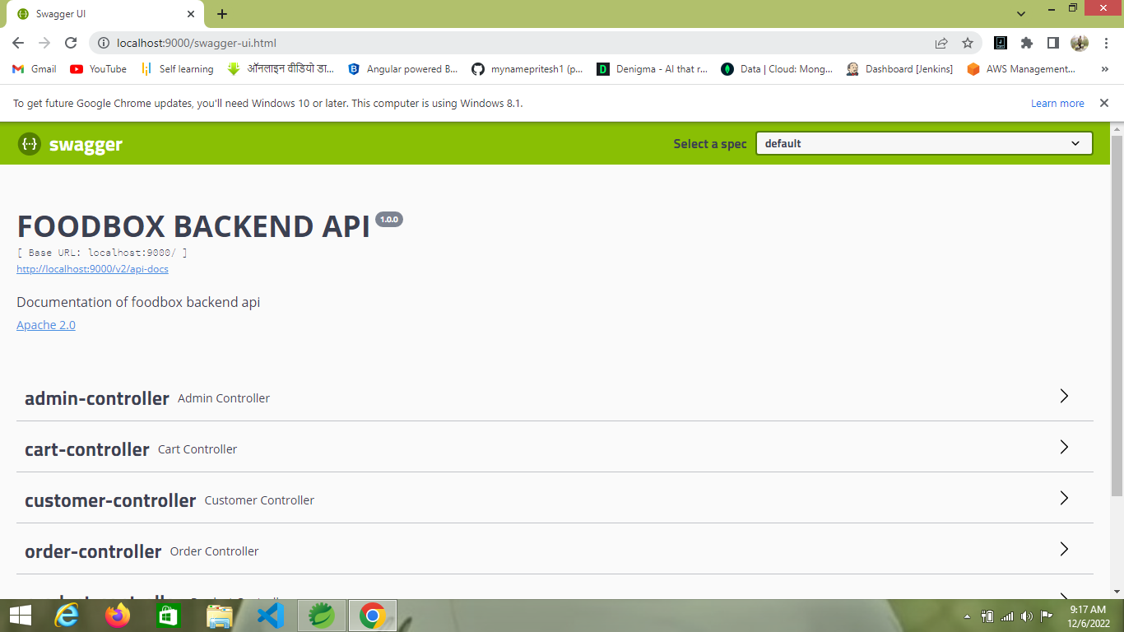

# 

# ER Diagram of MySQL Database

**These are my Tables and there Relation**

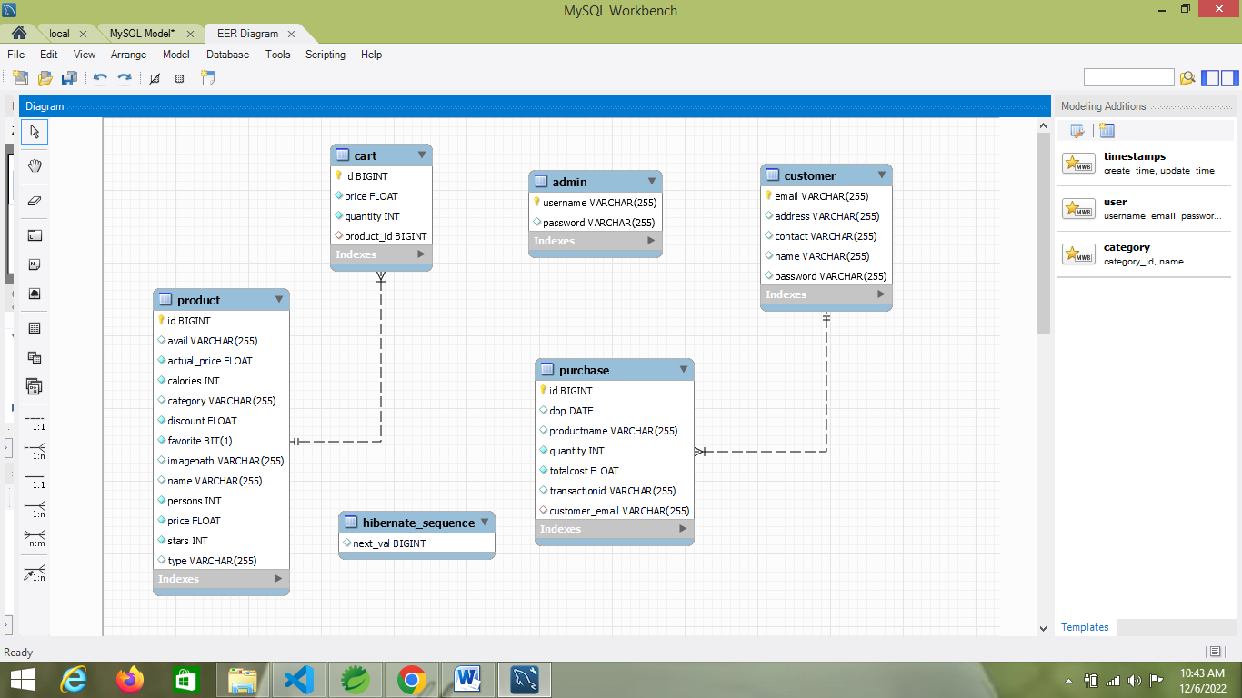

## Home Page of my Application…

## It is without login until user can login he cannot add or buy the food if he trying to add food without login there is error showing that you can login first then you can able to add this food to cart

**My frontend running on port 4200**

**When user can open application then he can see the register and login button and once he register and login then this login and register button will disappear and In place of that we can see cart icon and in Navbar also we can see my Account list in y account user can see he’s profile and order related thing**

**Even user can search food by using food name, type(veg or non-veg), category(Indian, Chinese, Briyani etc)**

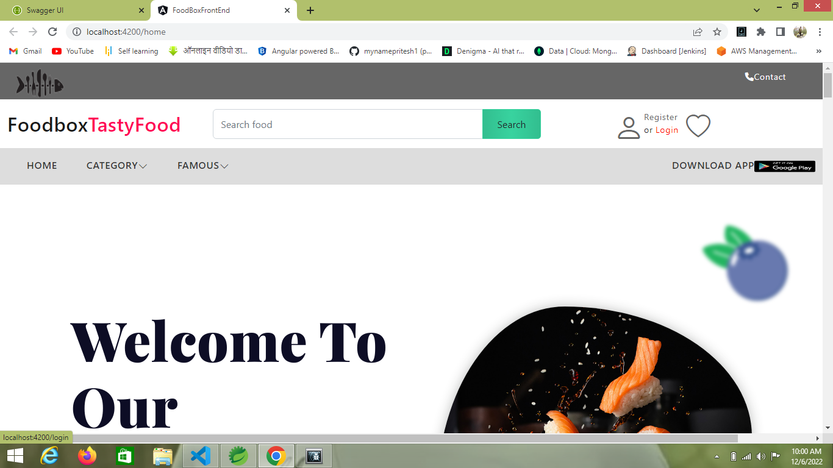

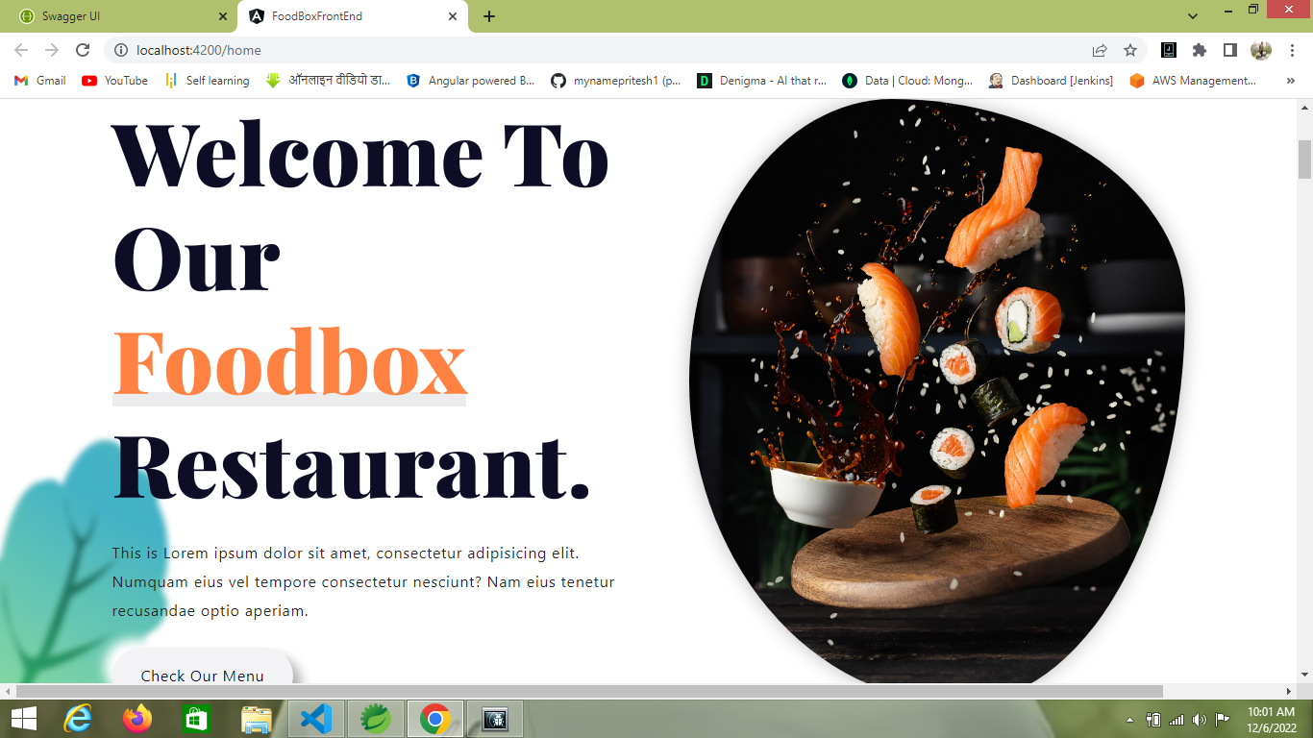

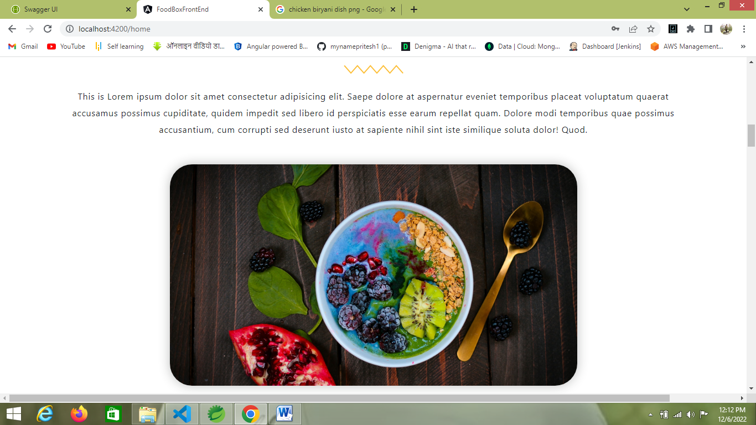

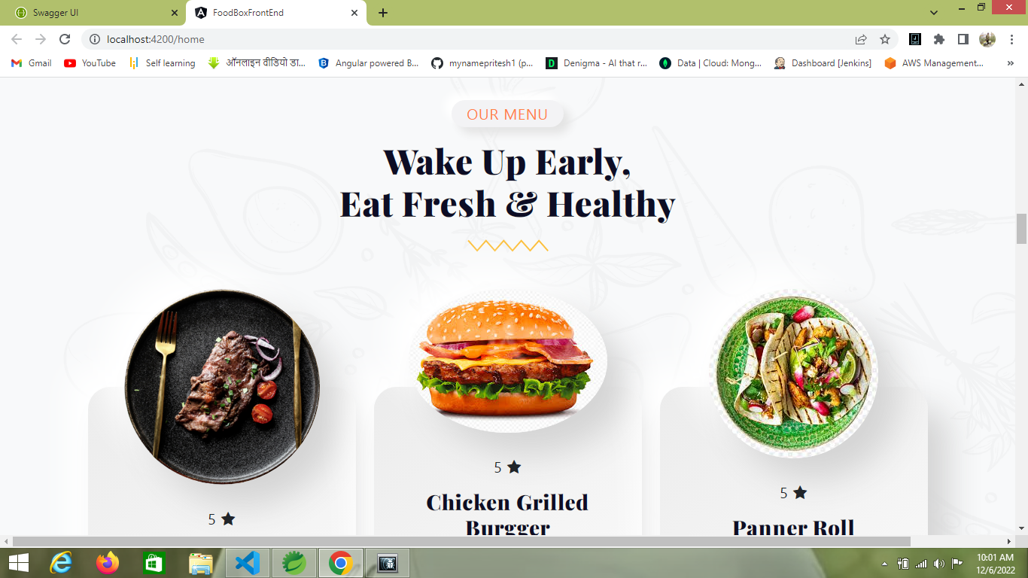

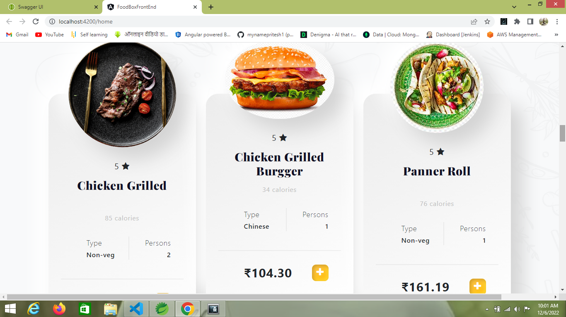

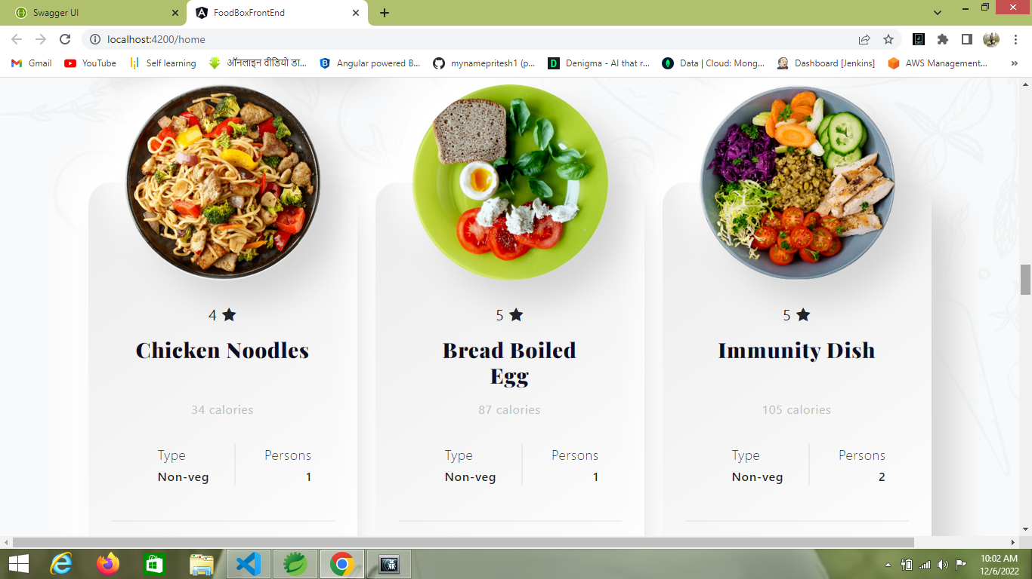

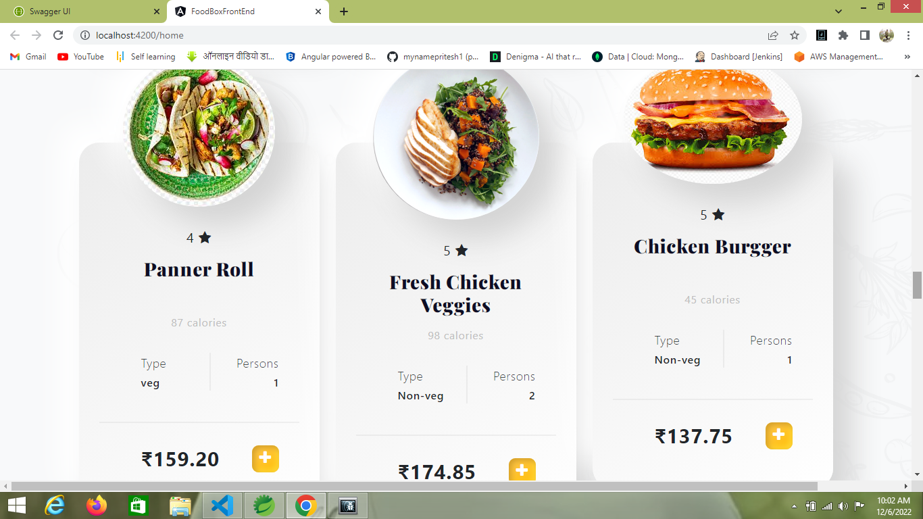

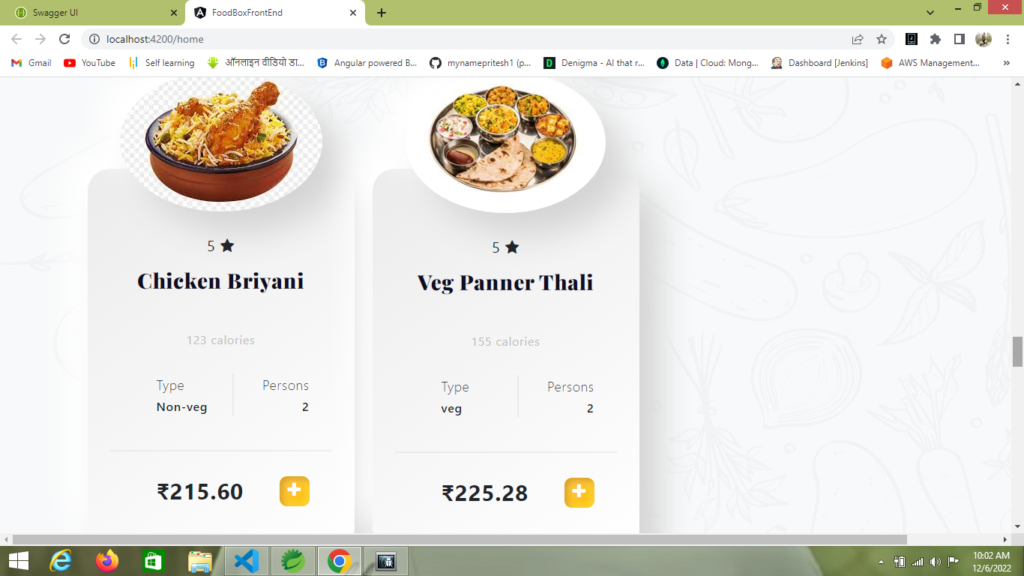

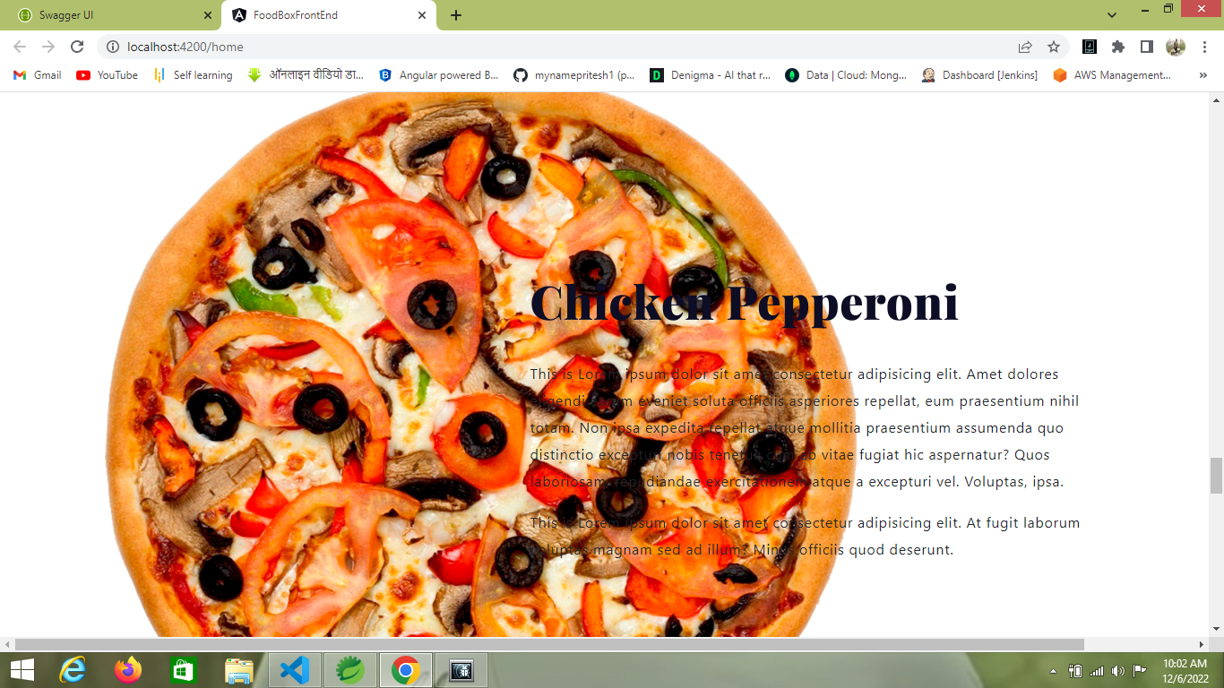

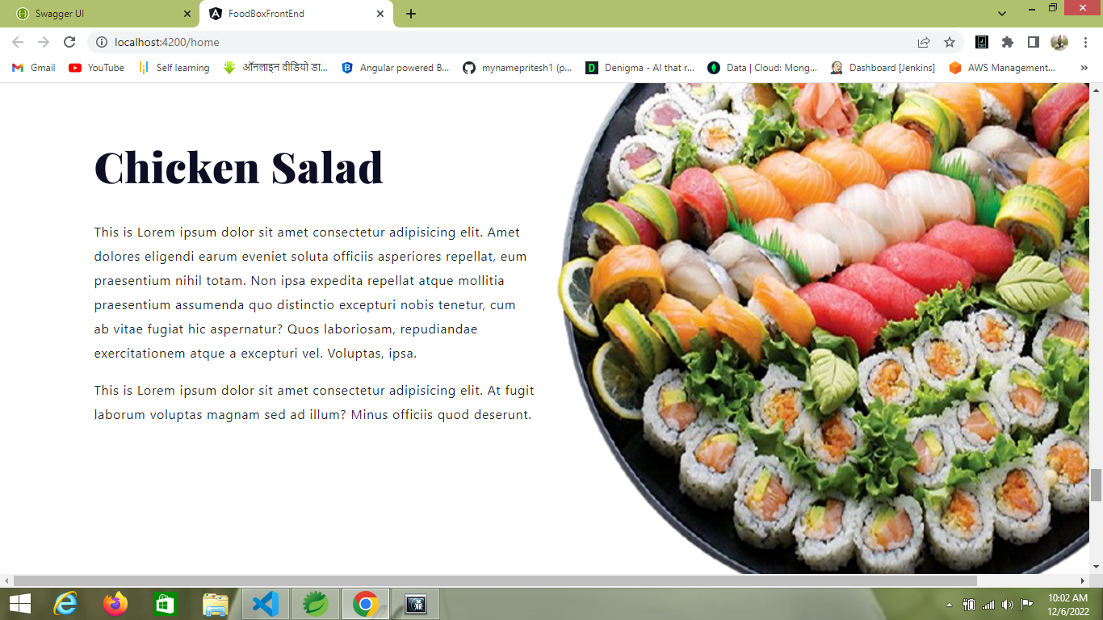

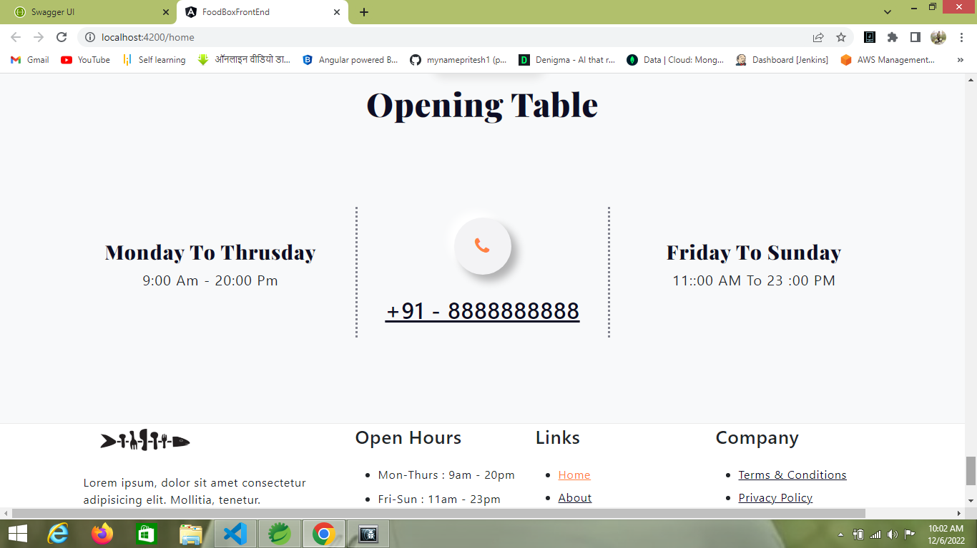

Above all I images shows only home page

**If without login user can try to add a food into cart then below error sees**

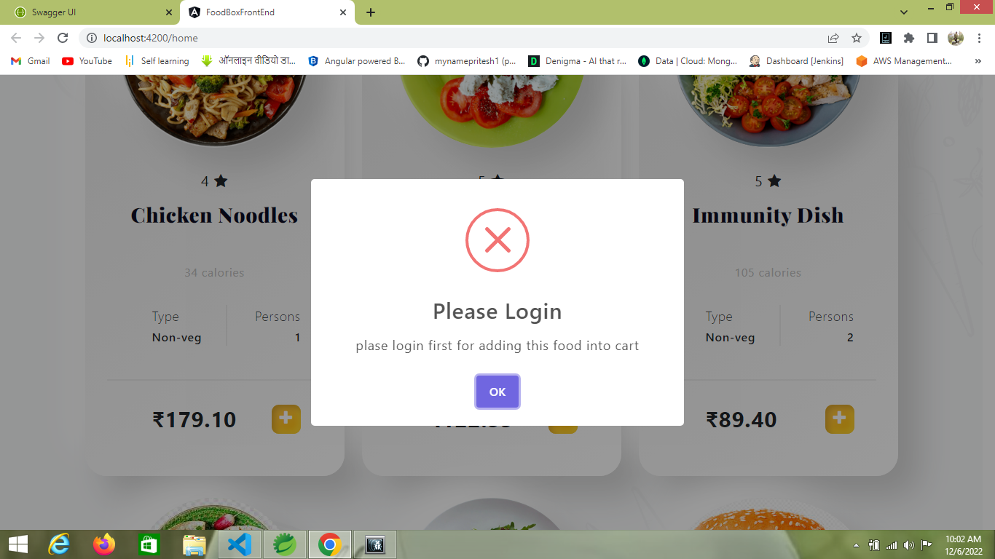

**Login page**

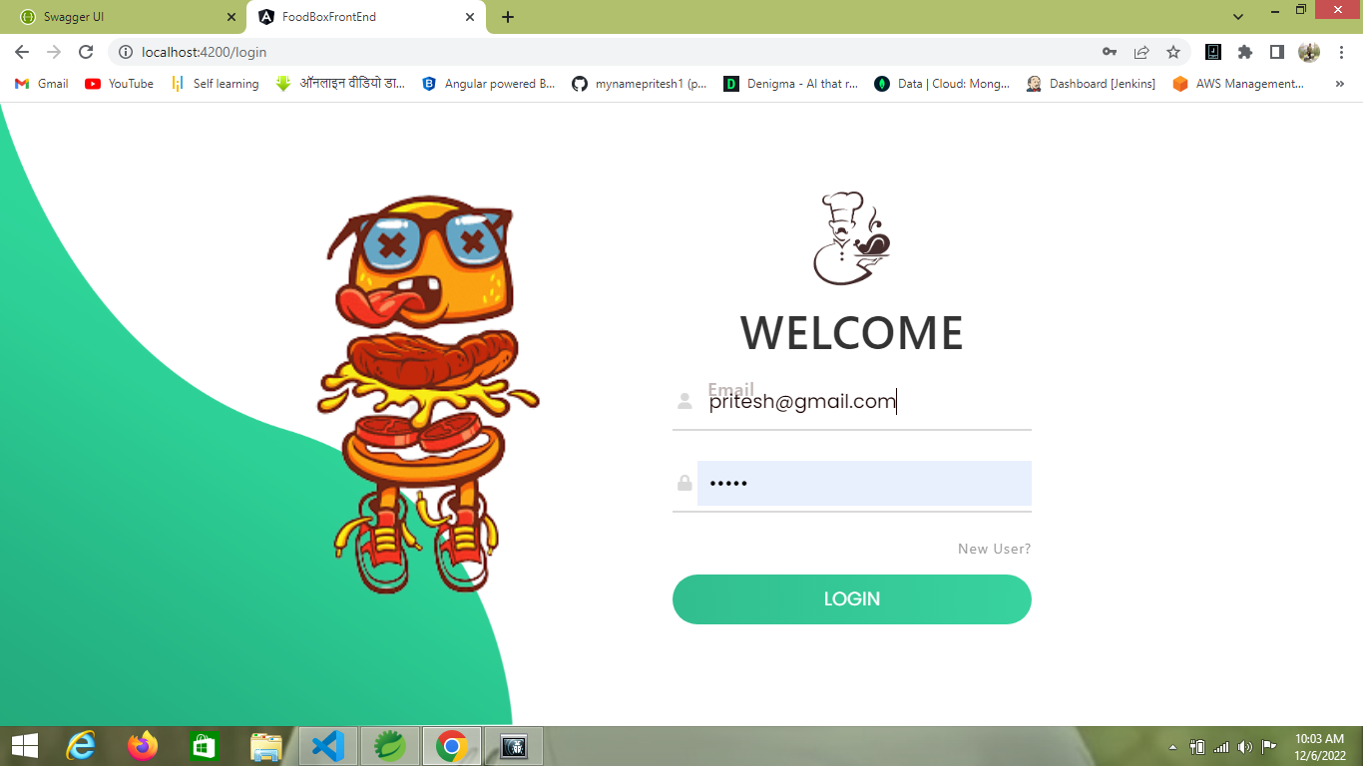

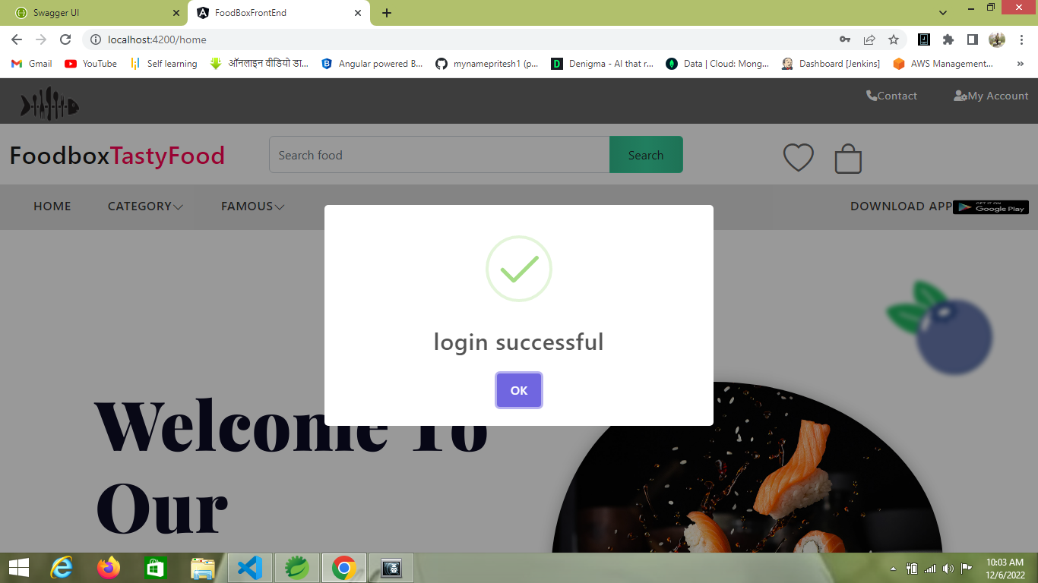

**Once user Successfully login then he automatically redirect to Home Page**

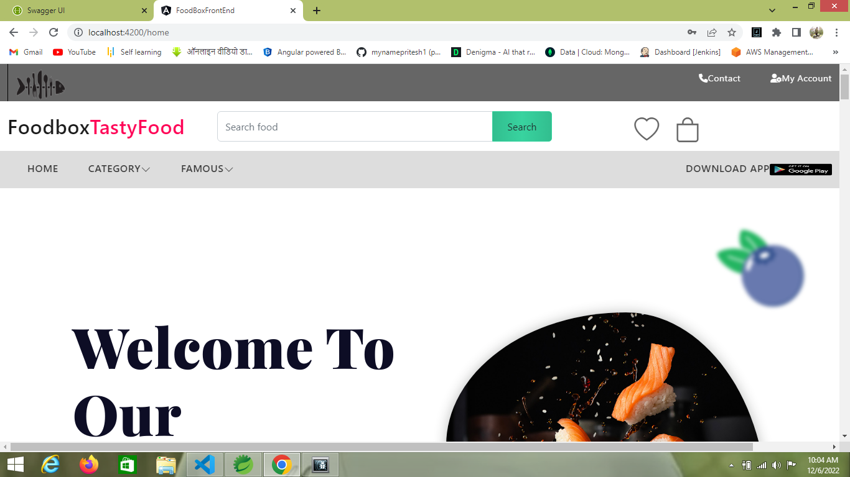

**After user login then login and register button is disappear and also we can see my Account button**

**Register Page**

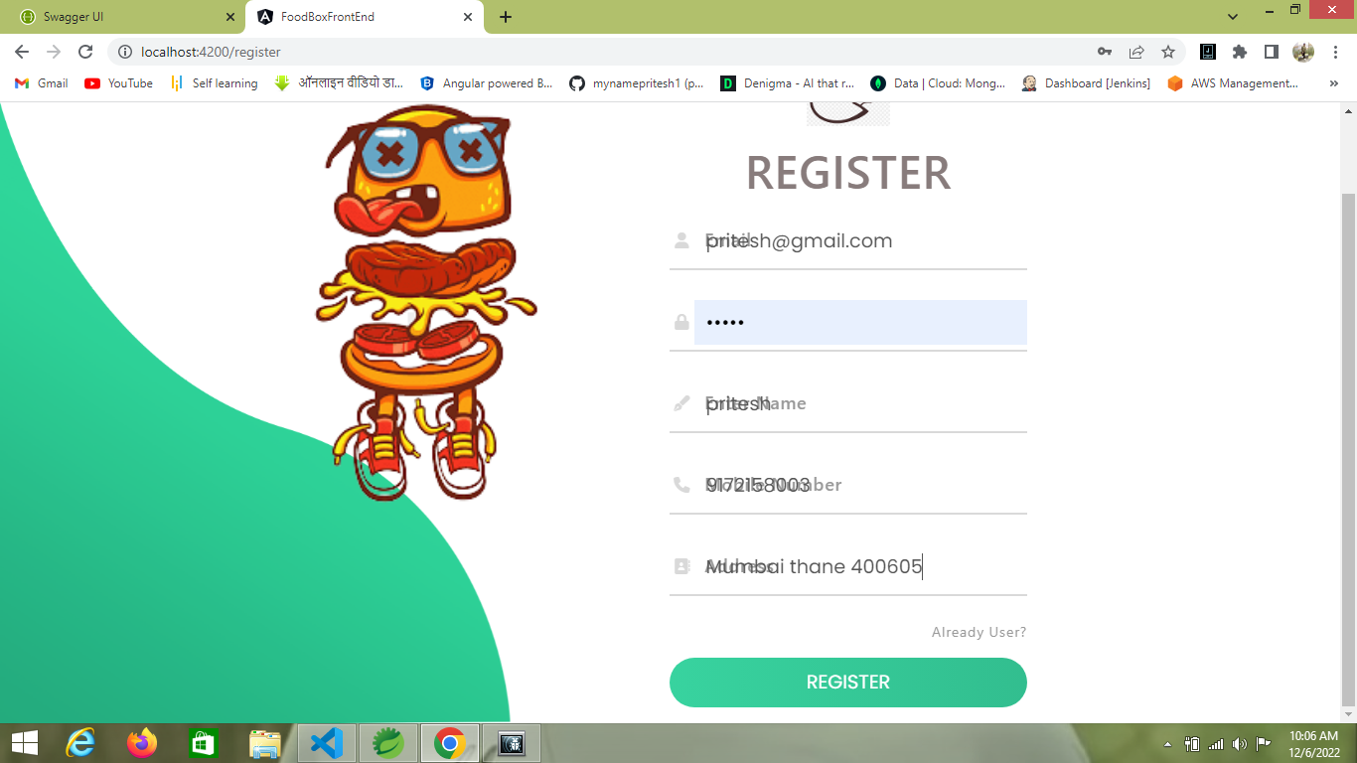

**After user login then can able to add food to cart and he can see successful message (for this alert I have used Sweetalert2)**

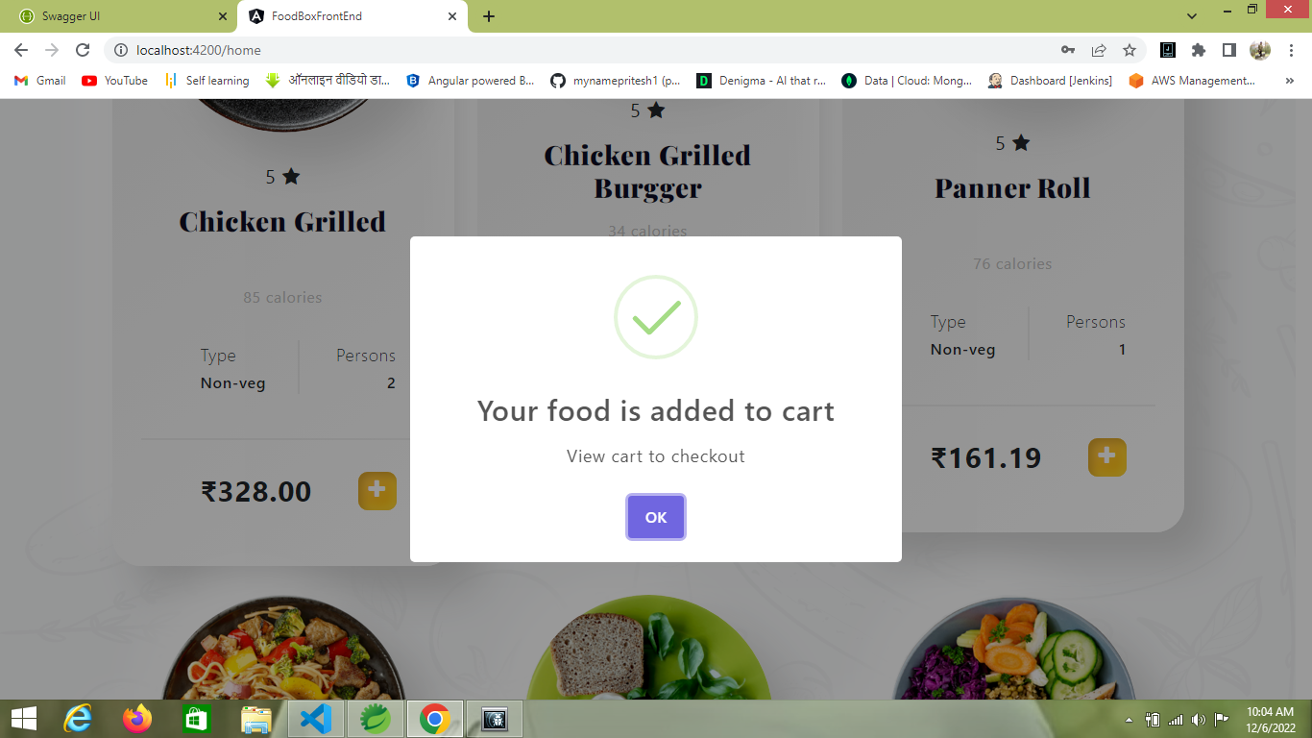

**If Cart is Empty then this message can see in cart and there is button continue shopping by clicking this button he happily redirect to Home page** 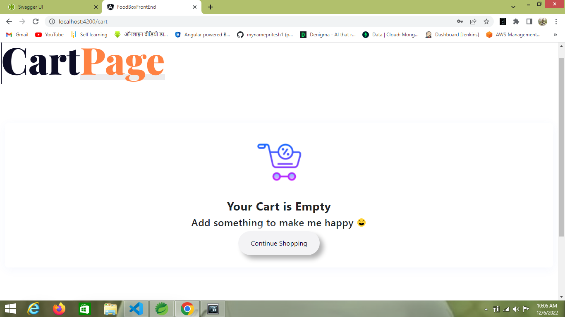

**Once user add food into cart then he can see he is food into cart page**

**In cart page if user added food then he can add or minus he is food item or else he want remove all food item then he simply use Remove button**

**And also there is checkout button for confirm the order**

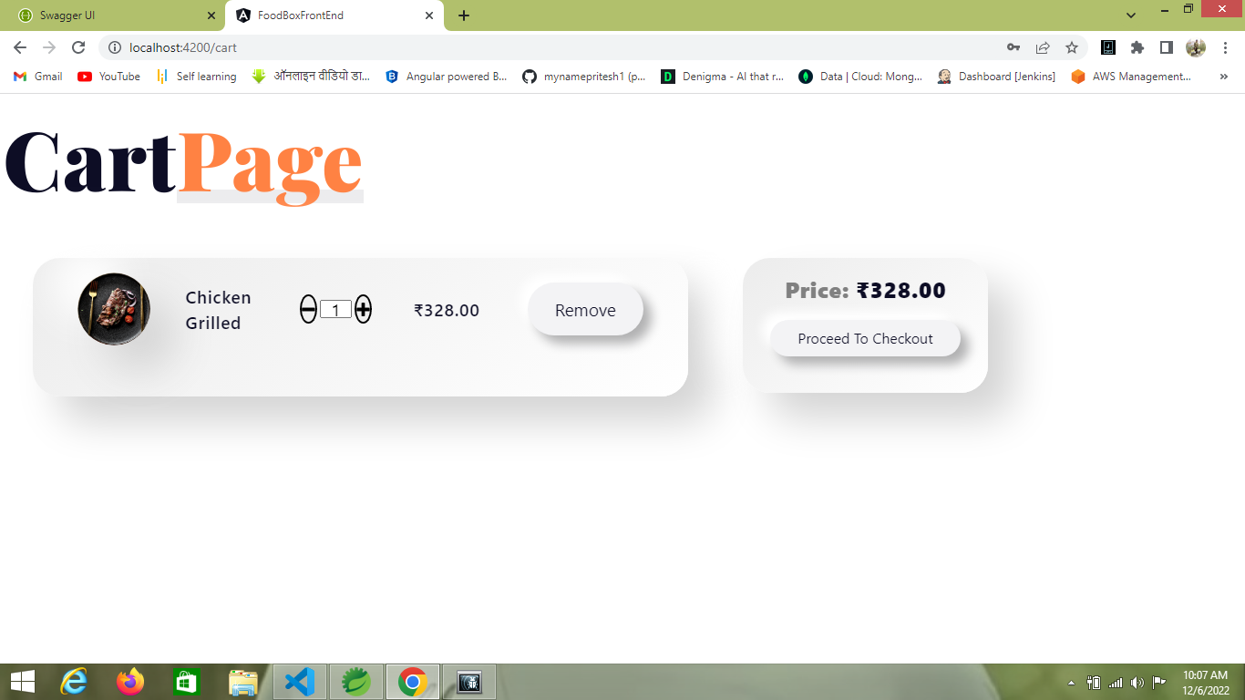

**After clicking proceed to checkout then he redirect to checkout/payment page**

**And he can sees he’s transaction id and also he can do card payment for checkout**

**Once he checkout then he see message that your order is confirmed and also redirect to confirmation page**

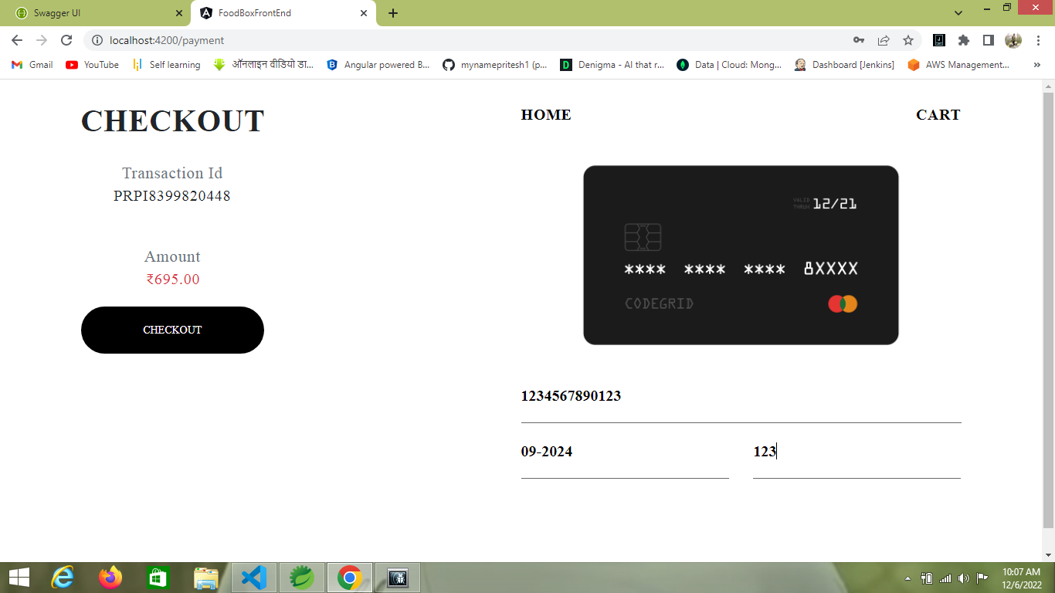

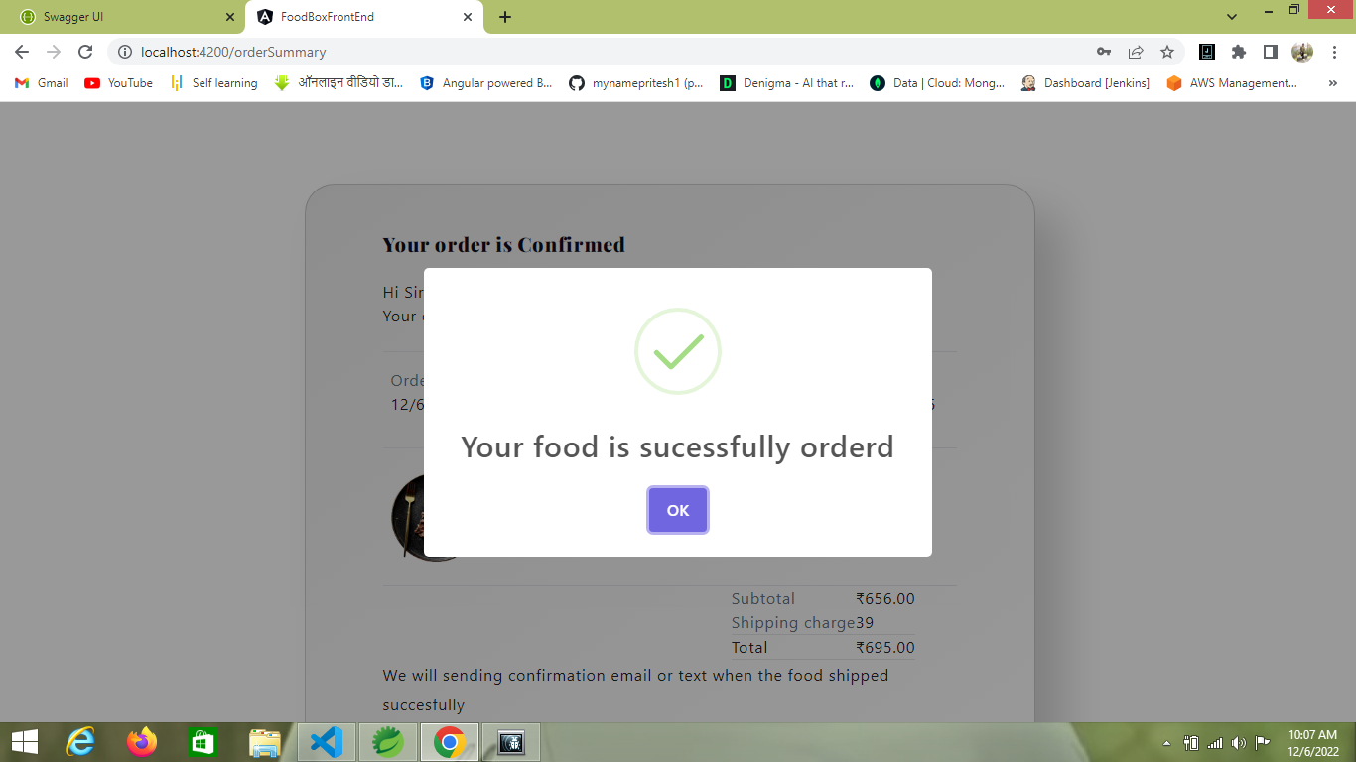

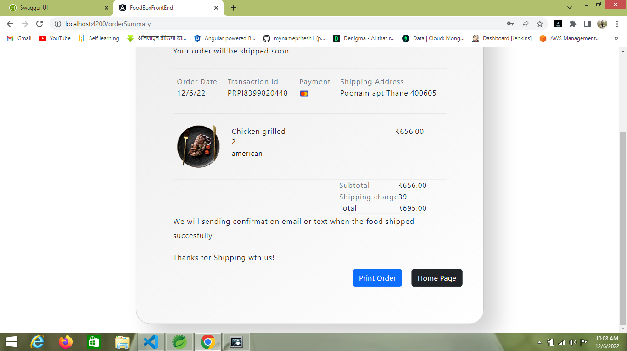

**Confirmation page**

**Print page user can print he’s order**

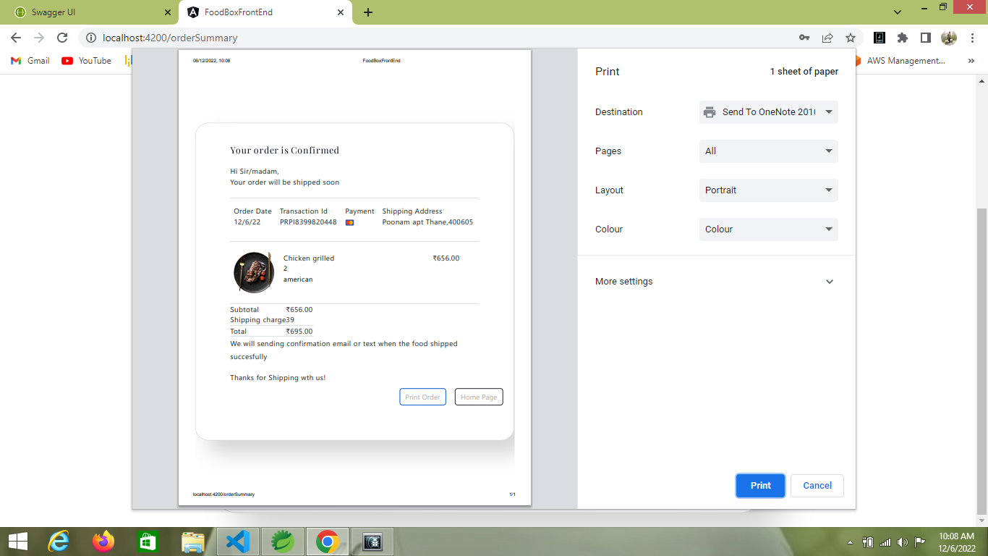

**This was only for user**

**Now we can see Admin login page and admin Dashboard.**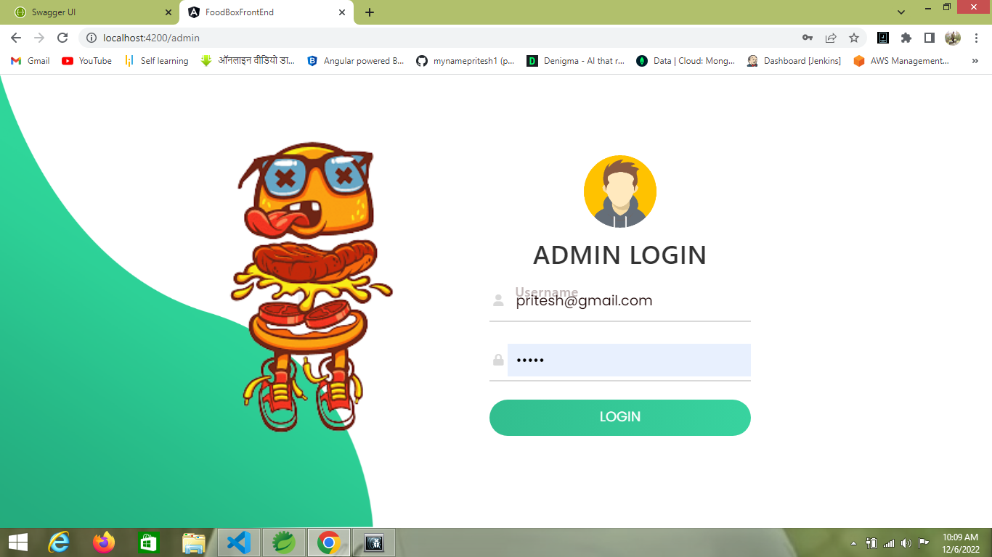

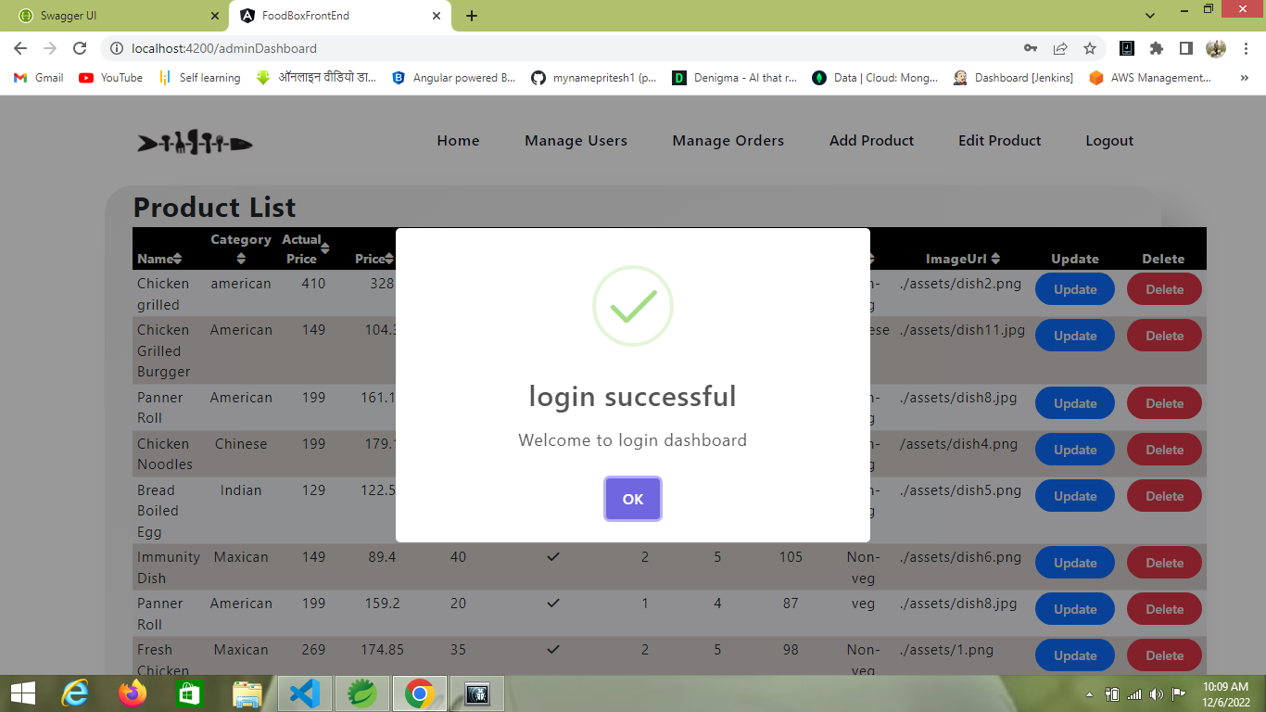

**Once Admin can login then he redirect to admin Dashboard and can add ,delete, update the food as well as maintain order and user list**

**Admin Dashboard**

**Product list**

**Here can add or update food by using update and delete button also there is Navbar**

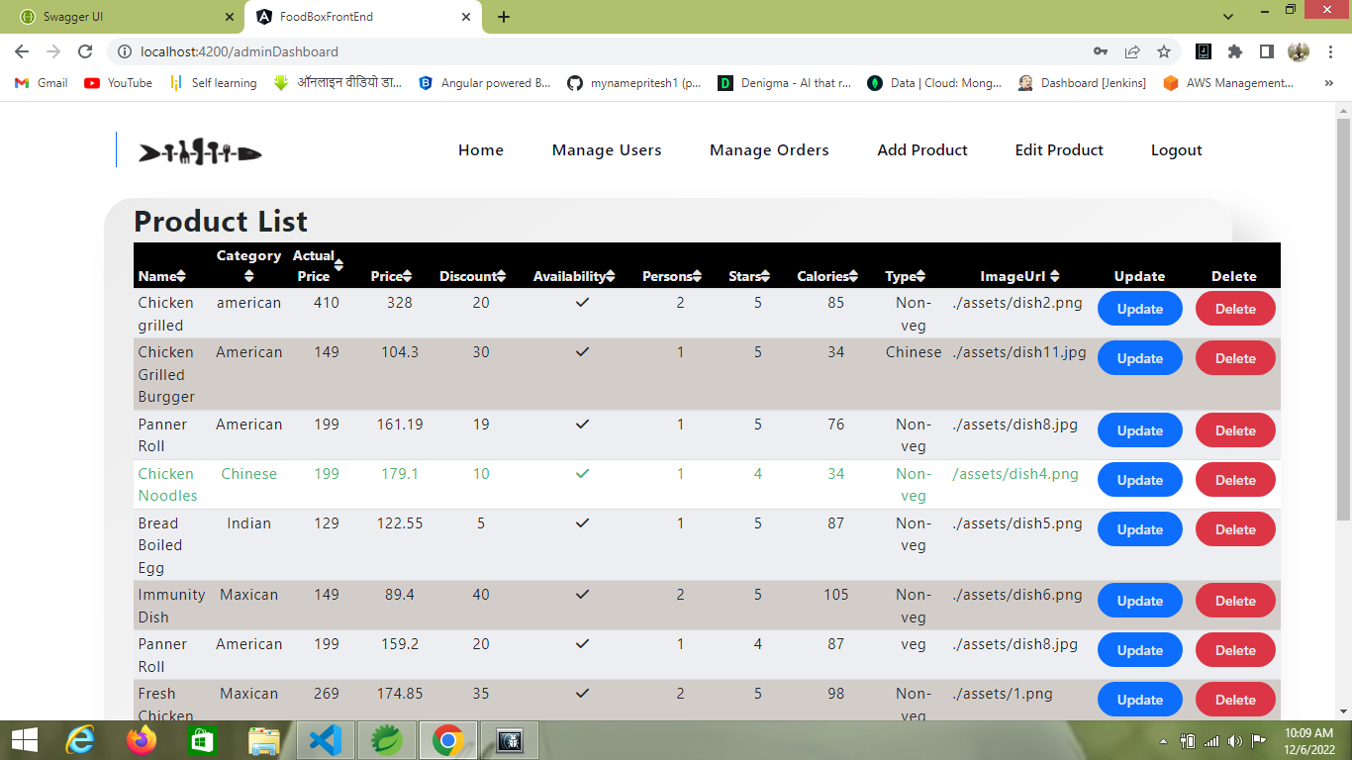

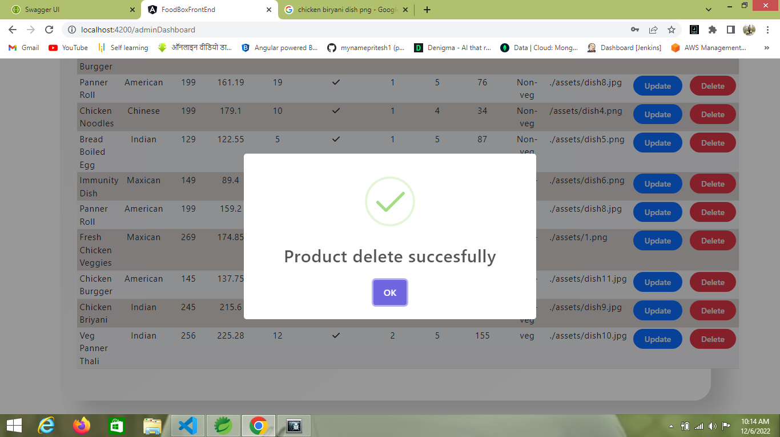

**User List**

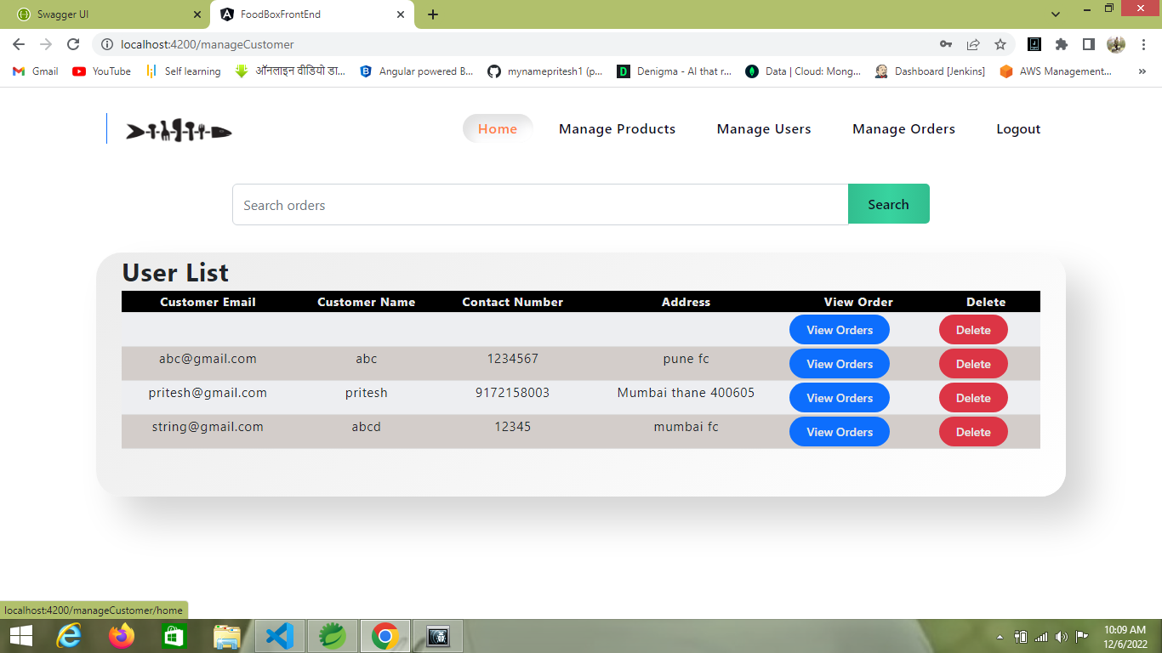

**Order List**

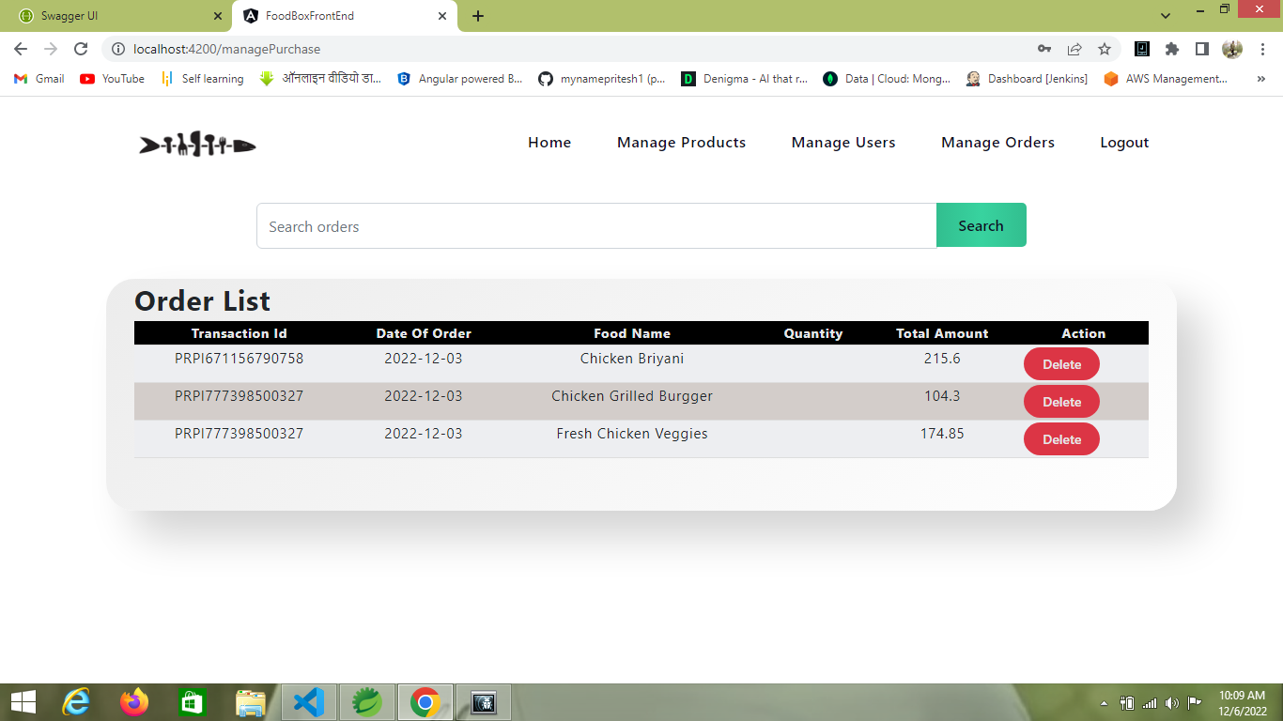

**Admin food Add page I have used modal for add food**

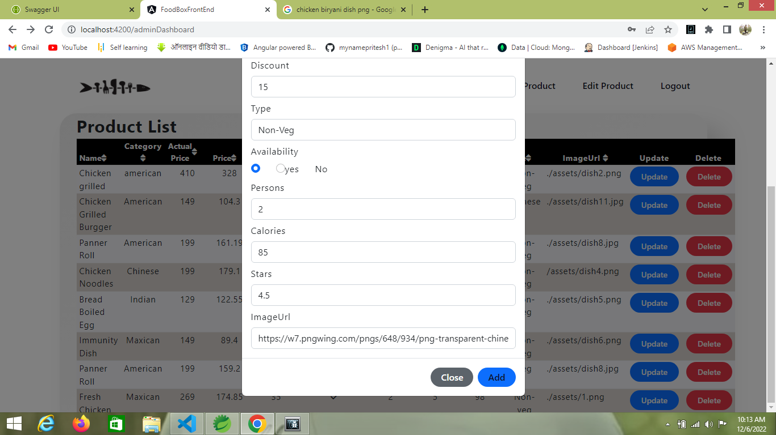

**Once he filled food form then he can see success message**

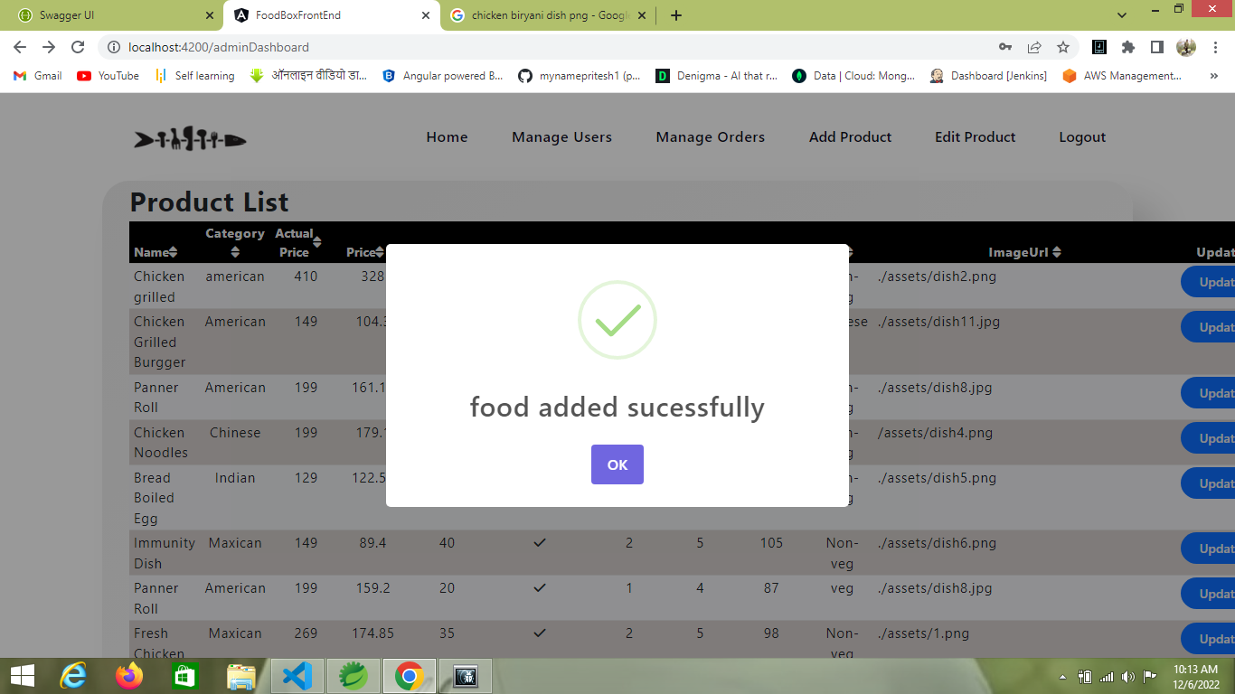

**Some Extra feature I have added in home page if user want see which category or which famous food we are offering then he simply hover on category and famous ul and he can click whatever he want to choose**

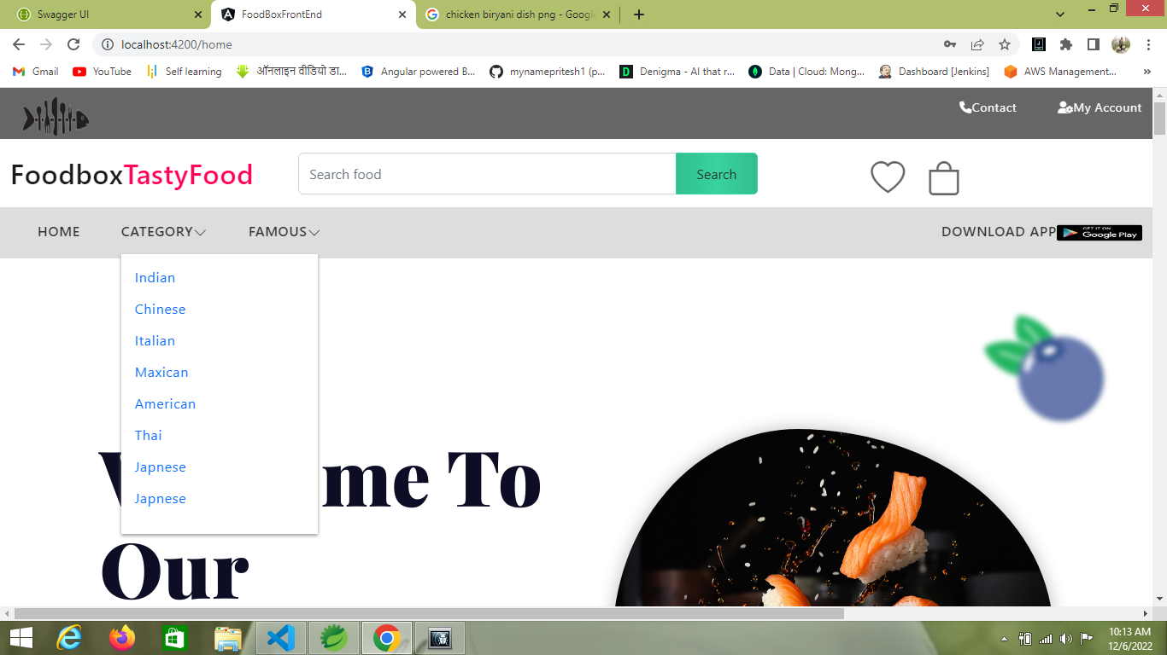

**Docker Image**

